Watervliet Elementary School

2557 10th Avenue Watervliet, New York

Main office phone: 629-3400

[www.watervlietcityschools.org](http://www.watervlietcityschools.org)

Mrs. Laura Abate, ESL teacher

[labate@vliet.neric.org](mailto:labate@vliet.neric.org)

ESL website:www.wesesl.weebly.com

[](http://www.google.com/url?sa=i&rct=j&q=&source=images&cd=&cad=rja&docid=6946SfV_rhSL_M&tbnid=Mt5E6qMPjQ9ZNM:&ved=0CAUQjRw&url=http://www.commbridge-translations.com/languages/&ei=6rXBUbTcK7eg4AOd54HIDg&bvm=bv.47883778,d.dmg&psig=AFQjCNEw9-WqTFkAXckx_9IKOE3DZZH10A&ust=1371735893743339)

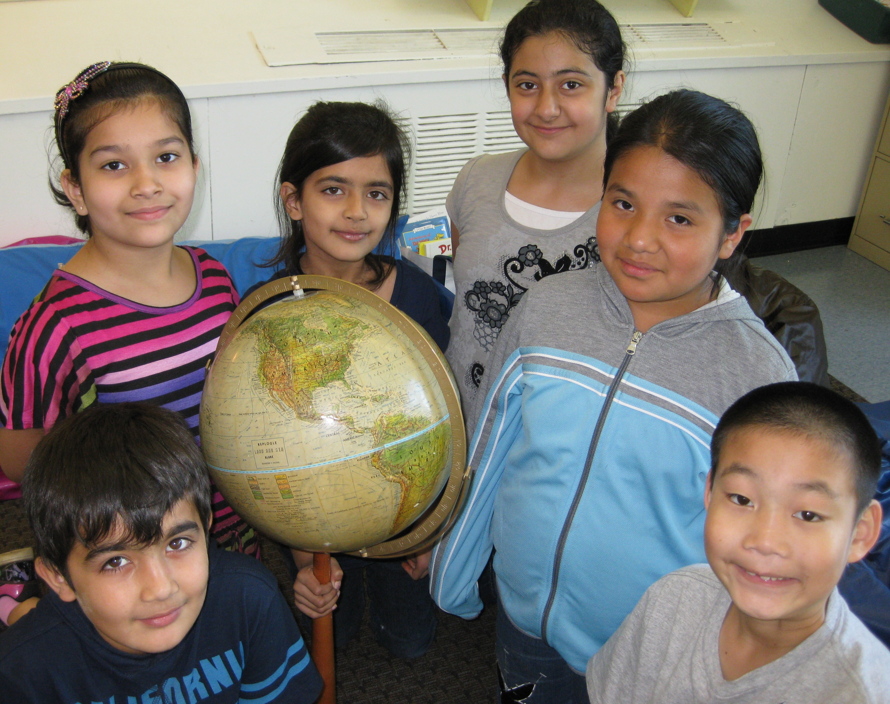

Watervliet Elementary School

ESL Program



Welcome to our School!

Almost 40 years ago, Watervliet Elementary School was opened in this building with 563 students. Back then, Watervliet already had a long history of diversity with many European groups settling in the area after coming to work on the Erie Canal in the early 1800’s. Today our school has more than 700 students whose families come from about 20 countries and speak more than 12 languages. We are proud of this wonderful cultural and linguistic diversity. The world is in our school!

Watervliet Elementary School serves about 25 students in its ESL (English as a Second Language) program, supporting bilingualism and the development of the English language skills needed to succeed in school and in life.

ESL Program

Identification

New students whose first language is not English are given an interview and a test (NYSITELL) to determine if they should receive ESL support.

Instruction

The ESL teacher provides either push-in or pull-out ESL classes (or a combination). These classes focus on learning all the language skills (listening, speaking, reading and writing) using academic content. The teacher works with students on areas of individual need.

Testing

ESL students take the New York State English as a Second Language Achievement Test (NYSESLAT) each spring to track their progress in learning English. Eventually they will test out of ESL services.

Parent/family support

The ESL teacher is available to help families with any questions and concerns about the school. She can be contacted by phone, email or by leaving a comment on the ESL website: www.wesesl.weebly.com. Feel free to send notes in with students as well. If you need a translator for a parent-teacher conference or any other school meeting, please let us know and we will try to assist you.

Important dates for 2014-15

**Meet the Teacher Nights** are a great way to get to know the school, your child’s new teacher and the academic goals for the year. Look around the building, your child’s classroom, and ask questions!

**September 15, 6-8pm Grades 1-3**

**September 17, 6-8pm Grades 4-6**

**September 30, 6pm UPK and Kindergarten**

**Parent teacher conferences** are a great opportunity to meet your child’s teacher and discuss his/her progress. If you need a translator, please let us know and we will do our best to find one.

**November 3, 6-8pm**

**November 4, 8am-3pm**

**Grandparents / Special Person’s Night** is a great event. Classrooms are open for family and friends to explore. Many special projects and work are on display, as well as band and choral performances. Stop in the ESL classroom.

**May 19, 6-7:30pm**

**Special Notes:** In the event of bad weather, the school will announce “snow days” (school is canceled) or delays (usually 2 hours) on the local TV and radio news stations, as well as on the school website.

If you would like to talk about the vegetarian options available for your child for lunch, please contact the school.